Chapter – 8
Operators:
Arithmetic:
The arithmetic operators are pretty basics.the modulus operator returns the number of times one number fits into the other 4 fits into others 10 into 2 times.you can create without assigning a value to the variable name.it is possible to type into the browser console for practice.
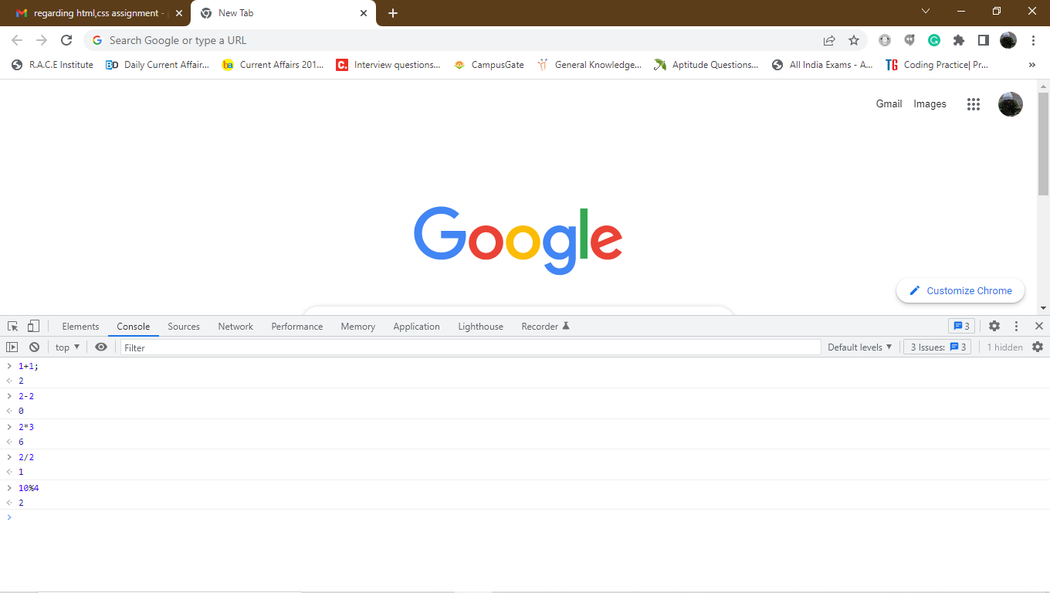
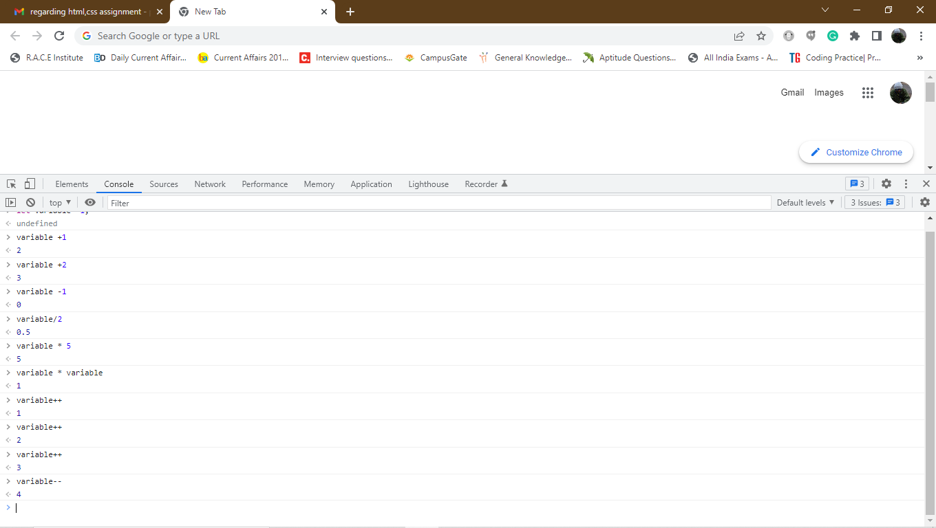
Assignment operator can assign a value to the variable.There are several assignment operator that can also combine assignment with one of the arithmetic operation.
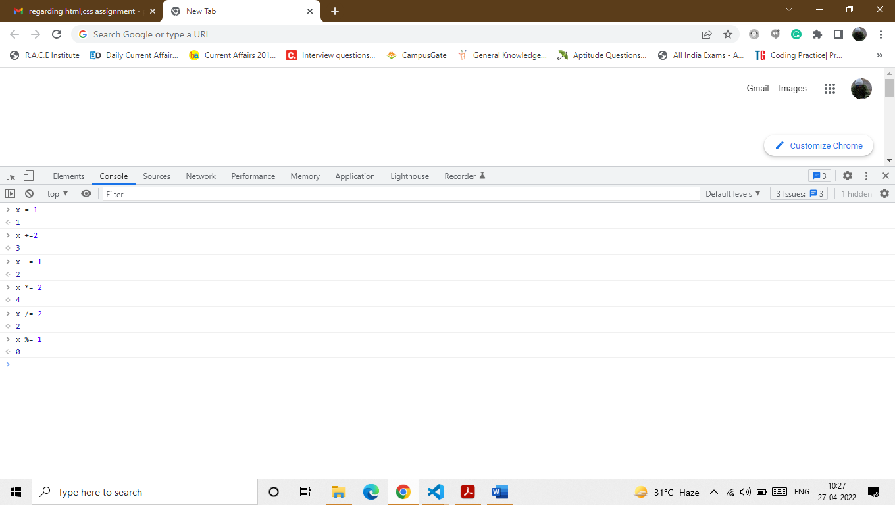
String:
Strings can be assigned to variable names or each other using a + operator.ut when one or both of the values on either side of the + operator are strings it is created using string addition operator.

Comparison:
Logical:
Logical AND operator if any one of the side Is false we get a result is also false.
Logical OR operator if any one of the side is true we get a result is also true.
Logical NOT operator if we get true then the result is false
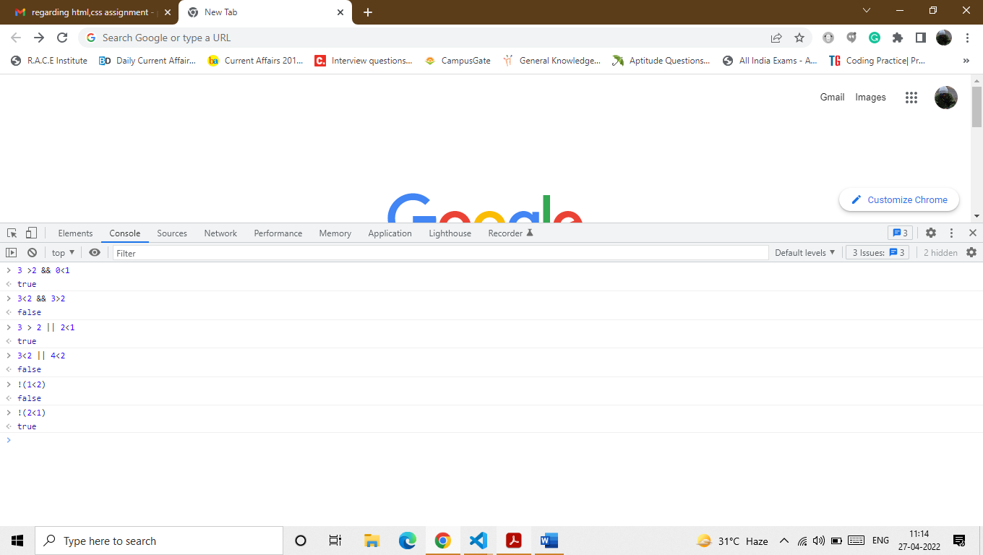
Bitwise:
Typeof:
The typeof operator is used to check the type of the value.It will often evaluates to either primitive type ,object or function.
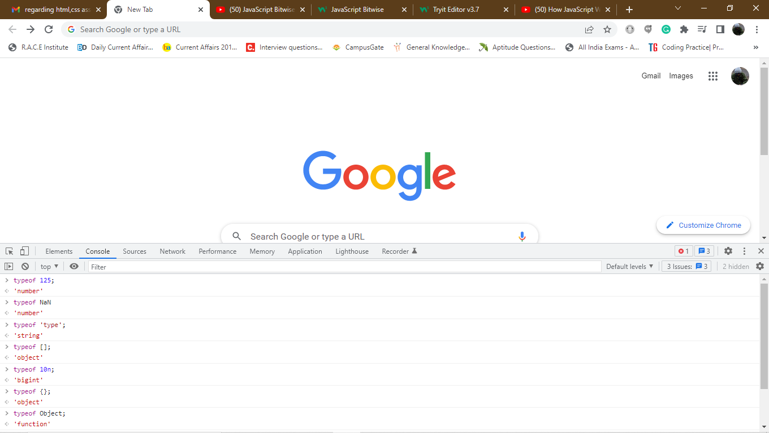
Ternary(?:)
The ternary operator is the form of statement ? value : value ;
The ternary operator is like an inline if statement.It doesnot supports a {} or multiple statement.
Delete:
The delete keyword is used to delete an object property.
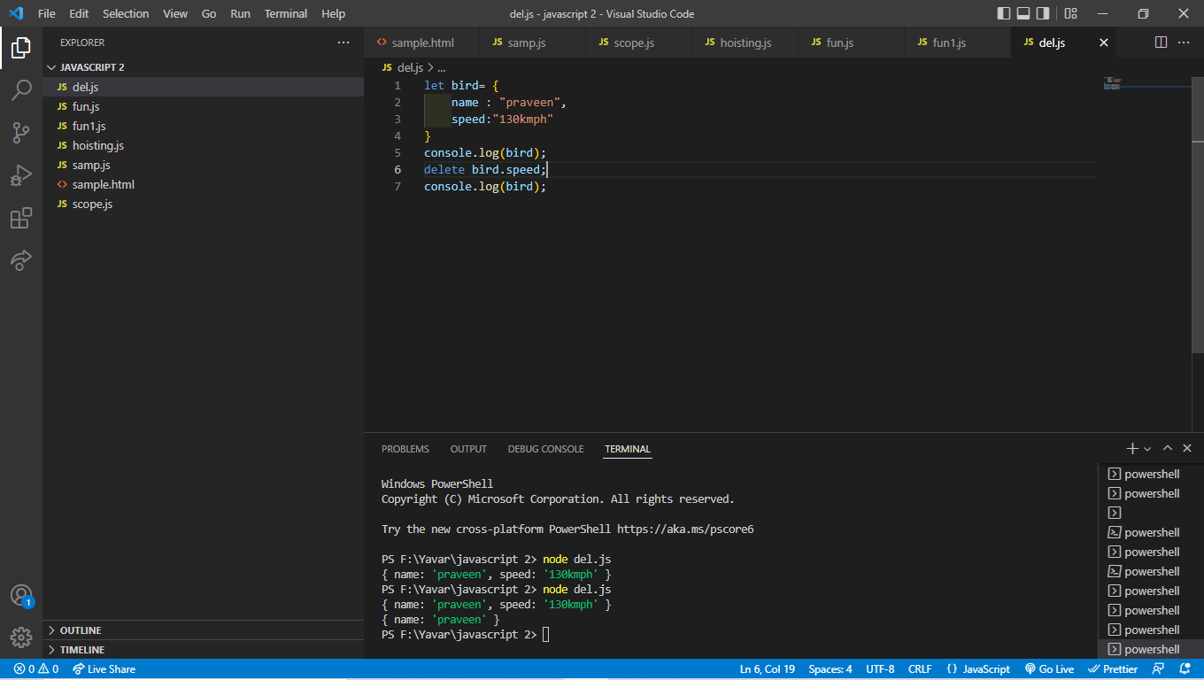
IN:
The in operator can be used to check if the property name can exist in an object.
